Objective: Review three different mockups according to the following criteria.

1. Will it take a little, lot, or absurd amount of work to build this feature/design?
2. Are there other options for similar result with less work?
3. Is it a good development choice? Do you have any concerns with it?
4. What would be the first dev step you would try when building? Ex: “Add border radius to curve the edges” or “Something with SVGs”. This doesn't have to be terribly specific, just do your best.

Mockup 1:

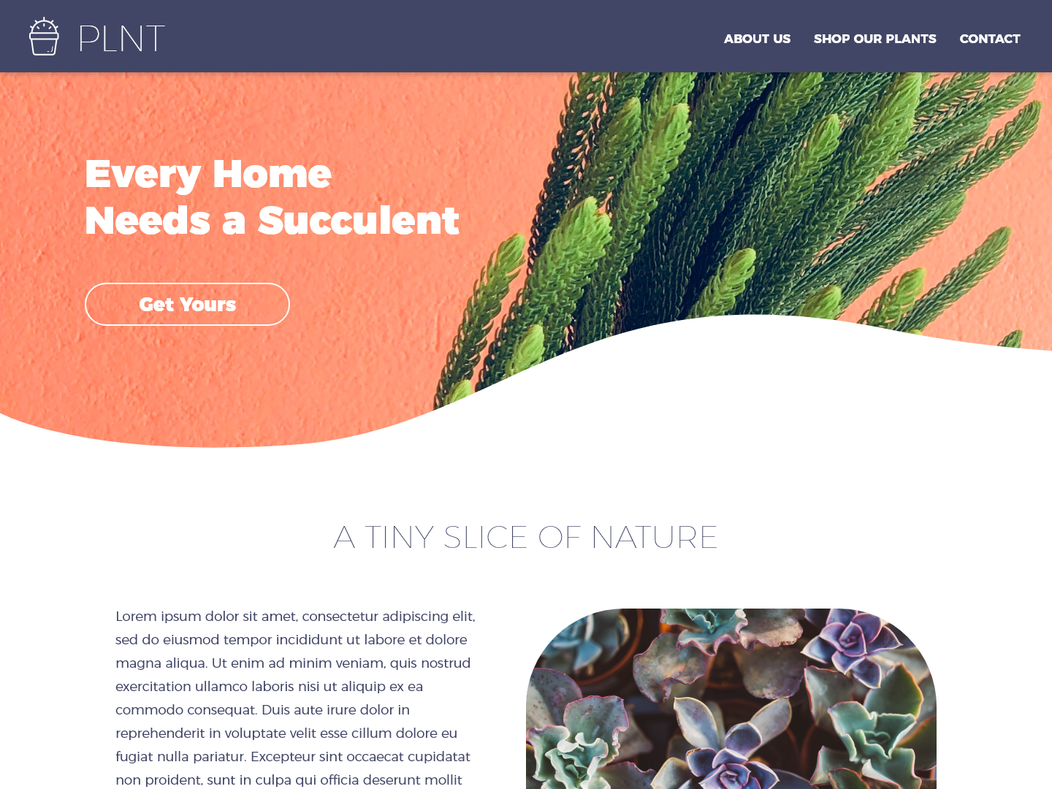

1. Overall, this design should take a lot of work to build, with the biggest time chunk being spent on designing the wavy top banner. The remainder of the page is relatively straight forward (navbar, header, and body text/Image).
2. Yes, a rectangular banner would yield a similar result (albeit with less artistic flair). You could also do a banner with a linear gradient or one that has rounded corners, similar to <https://codepen.io/ummummhm/pen/vgLqLw> (see insert below)

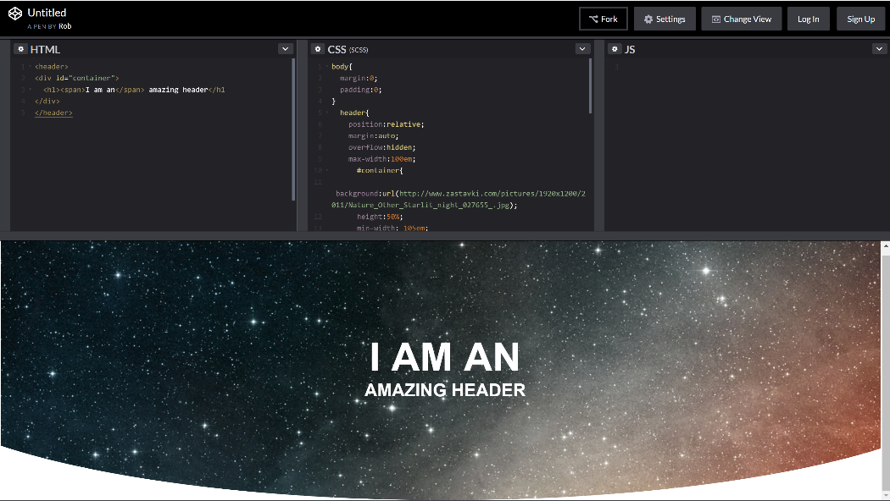

1. yes – I would make a tiny slice of nature bold or darker, as well as the body text, since readability is lower there. There is good contrast on the succulent part (though I question how the wavy bottom fits into the theme of succulents or plants. I’m not sure the wavy design format would be responsive across different sized media.
2. The first dev step I would I try is to layout the page in a grid format, with the top being a nav bar, the icon and PLNT being floated left, and the about us, etc links being floated right. I’d use css to set the color and typography. I’d start with a simple curved banner, and insert a clickable link onto it for “Get Yours.” The bottom part is a h1 or h2 header and two columns one being filled with an image and the other with left justified text. The columns appear to be padded in about 15 percent of the page. Then after researching for a few extra minutes, I’d probably implement one of the following approaches found on the internet for the wavy portion: (see <https://www.youtube.com/watch?v=pxDgD5JWdqg> (uses Adobe Illustrator); and <https://stackoverflow.com/questions/17202548/wavy-shape-with-css> (pure css)).

Mockup 2:

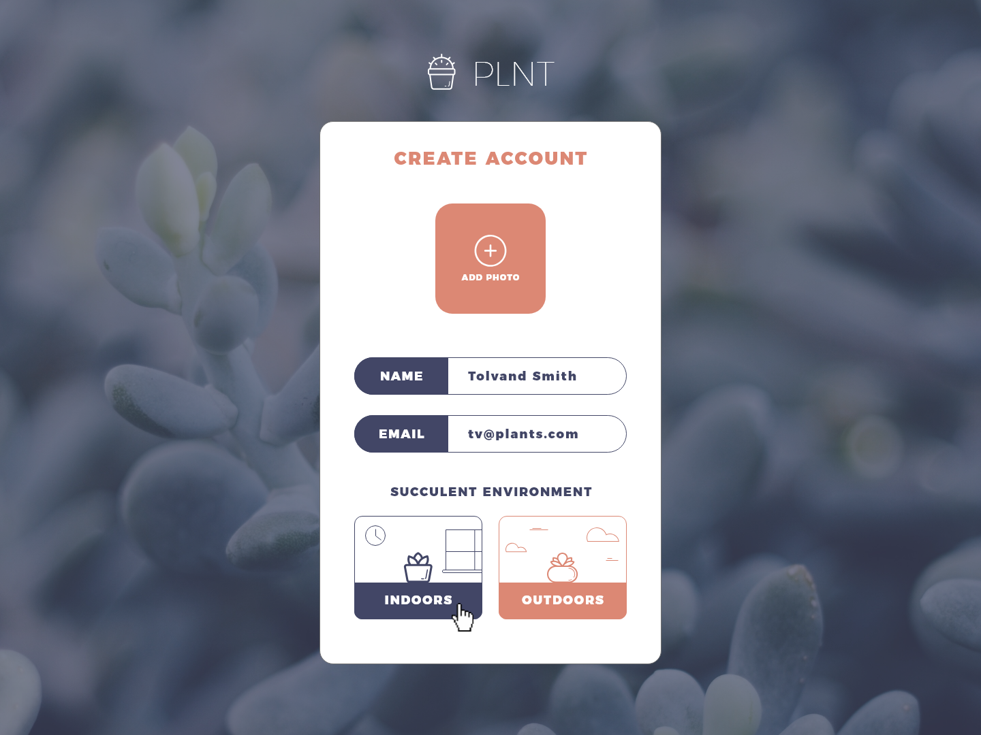

1. For me personally, this would take a lot of work. I would need to create custom button for indoor and outdoor plants and possibly the add photo icon. The rest of the form would take little work
2. Yes, replacing the custom icons with boxes that respectively say indoors and outdoors.
3. Overall, yes – though I’m sure how I feel about the visibility of the white on orange and if the contrast will be high enough to allow for individuals with vision problems. Succulent portion of environment might be confusing to some users.
4. The first step would be to build out the form using non-custom icons and then go back and insert in the created icons. It appears to insert the custom image, one would need to load a background image (of the created icon with text or subsequently overlay text onto the image) in css. Clicking on the indoors/outdoors button will submit the form and presumably fill in an environment variable with either indoor or outdoor. In addition to indoor/outdoor, you’d be potentially saving a photo, user name, email address to the user’s record. I’d presume that only the photo is optional to create the account..

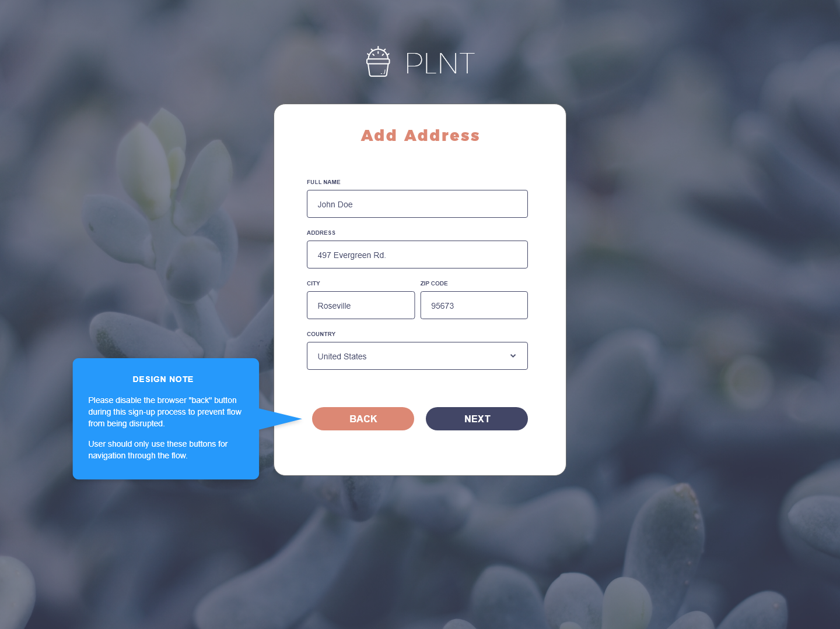

1. The form itself overlaid onto a background image will take a little work.
2. Not really, the form itself appears to be really straight forward
3. Yes and no – the form itself is a standard address entry form. You have your continue and go back to where you were button (such as checking out). Changing back to cancel, might lead the user to think they are aborting their purchase/sign-up, for example. The one major concern here is disabling the back button – which something you cannot really do (though you can make it difficult for the user to go back). As a user myself, I strongly dislike when a company prevents me from using the back button (I prefer a warning instead if it is mission critical).
4. I might create a form with inputs for each of the fields, two navigation buttons, which are essentially go to the previous form/page and to the next/form page. The values would be saved using javascript/json. To prevent the backbutton (if the designer wanted it), I would probably do something in javascript similar to this: <https://codepen.io/dhavalt10/pen/rGLBzB>. (essentially history.pushState(null, null, location.href); window.onpopstate = function () {history.go(1); }; in javascript).